**Why context is critical**

In this lesson, you have been learning about the importance of context in business intelligence. As a refresher, context is the condition in which something exists or happens. For example, in a previous video you considered this data visualization:



This line graph just shows five different lines on a grid, but we don’t have any information about what the lines of the graph represent, how they’re being measured, or what the significance of this visualization is. That’s because this visualization is missing context. Check out the completed version of this visualization:

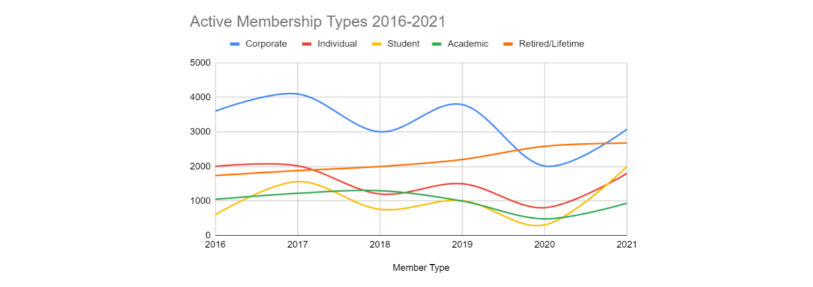

This visualization has all of the information needed to interpret it. It has a clear title, a legend indicating what the lines on the graph mean, a scale along the y axis, and the range of dates being presented along the x axis. Contextualizing data helps make it more meaningful and useful to your stakeholders and prevents any misinterpretations of the data that might impact their decision-making. And this is true for more than just visualization! In this reading, you’ll explore a business case where context was key to a BI project’s success.

**The scenario**

The CloudIsCool Support team provides support for users of their cloud products. A customer support ticket is created every time a user reaches out for support. A first response team is in charge of addressing these customer support tickets. However, if there is a particularly complex ticket, a member of the first response team can request help from the second response team. This is categorized as a consult within the ticketing system. The analytics team analyzes the ticket and consults data to help improve customer support processes.

Usually, the consultation request is fulfilled successfully and the first response team is able to resolve the customer’s ticket, using guidance from the second response team. However, sometimes even the second response team isn’t able to fully answer the question or new details about the case require additional insight. In that case, the first response team might ask for another consultation, which is labeled as a reconsult.

This is all important context for a BI professional working with stakeholders who are interested in how well current support processes are working and how they might be improved. If they build reporting tables and dashboards that only track consults and not reconsults, they might miss key insights about how effective the consultation system truly is. For example, a high reconsult rate would mean that more cases aren’t being resolved in the first or second attempts. This could lead to customers waiting longer for their issues to be resolved. The leadership would want to evaluate these processes.

Knowing this context, the BI professional working on this project is able to build out appropriate metrics, reporting tables, and the dashboard that tracks that metric in a way that helps stakeholders make informed decisions about this process. By understanding the business context, BI professionals can create more meaningful reports.

**Conclusion**

Context is the who, what, where, when, and why surrounding data that makes it meaningful. Knowing this background information helps us interpret data correctly and visualize useful business intelligence insights for stakeholders. When BI professionals understand the context, choose the right data, and build contextualized visuals to share with stakeholders, they can empower businesses and leadership to make successful decisions.